**1] less f4**

This prints the data in f4 file page by page and we use space to reach last and enter for next line and ‘b’ for back, ‘q’ to quit the process

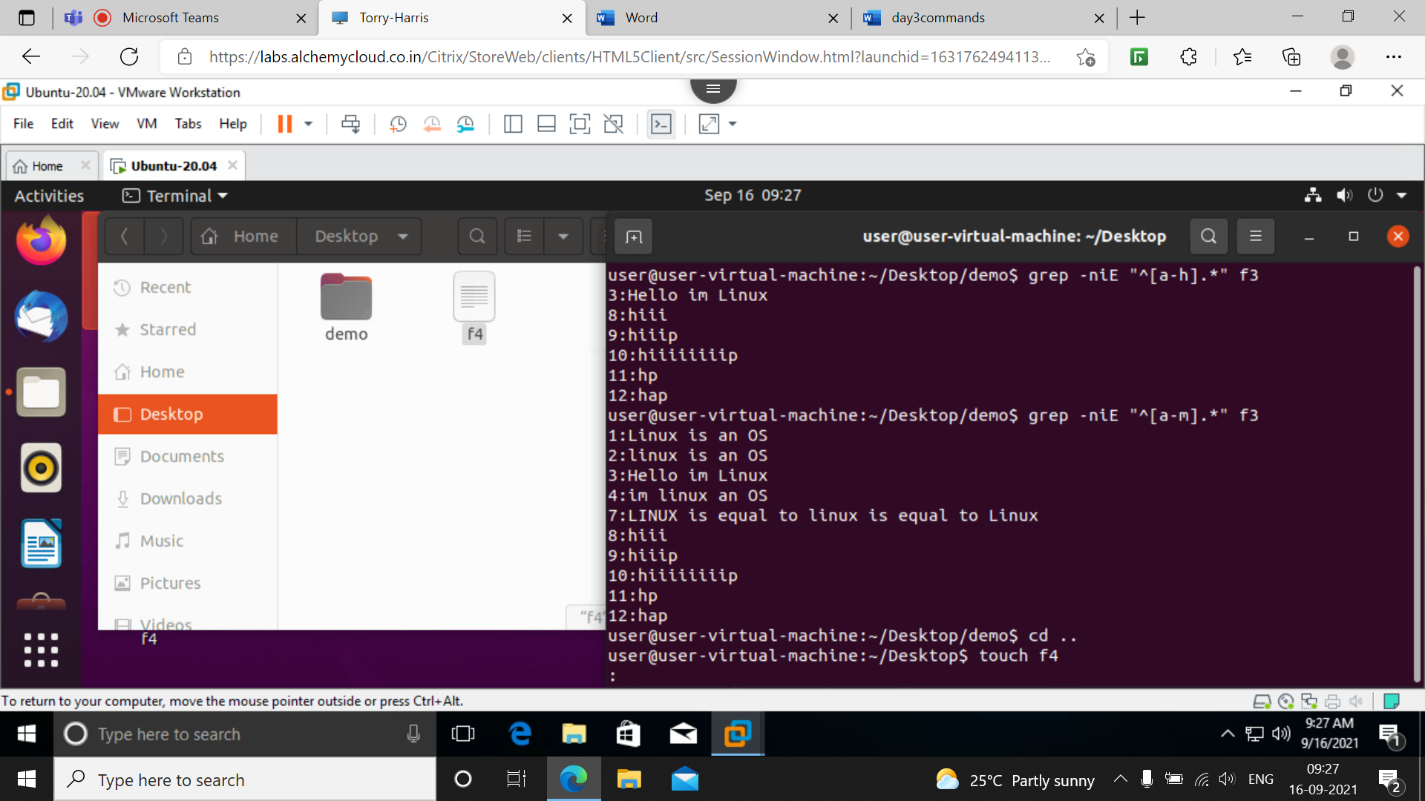

**2] less –N f4**

This prints the line number corresponding to paragraph or line

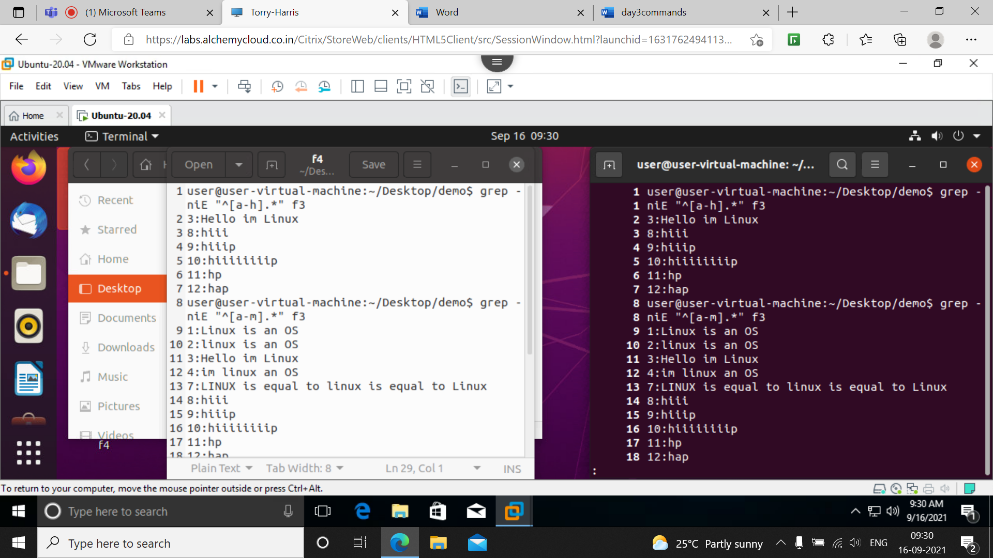

**3] less –p ‘hii’ f4**

This command finds the word ‘hii’ in file f4 and start execution when first it encounters hii

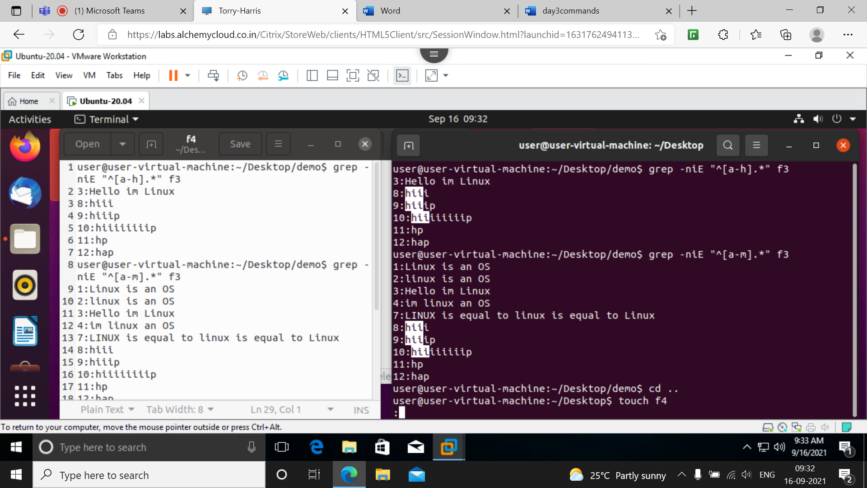

**4] vim**

This is home screen of vim we can goto insertion mode by pressing ‘a’ or ‘i’ then we can write our file

To save the file exit from insertion mode then press *:w filename* it wll save

To open file from terminal use *vim filename*

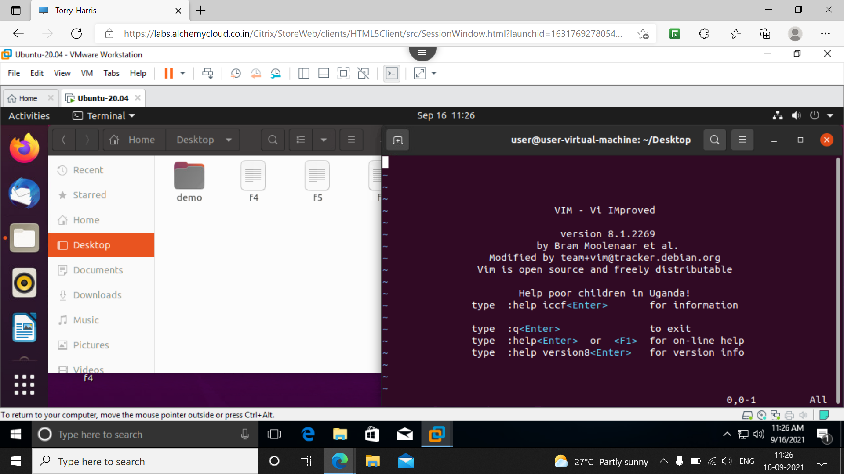

**5] Vim f5**

**T**his command is used to open the f5 file saved and data will be displayed

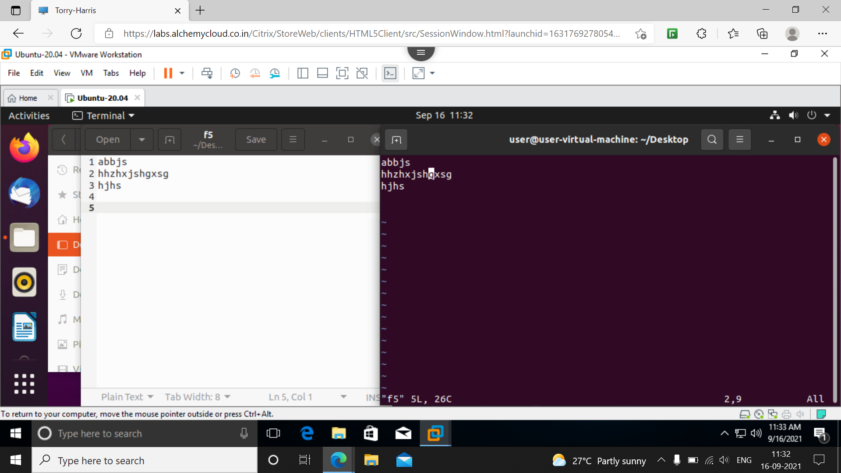

**5] :q**

To exit the terminal of vim

**6] :q!**

To exit terminal without saving file

**7] :w filename**

To save the file after writing the data

**8] :r filename**

This is used to copy the data from one file to existing file in insertion mode

Here below the data of f6 is copied to f5 and displayed on screen

And if we want to save the existing file press esc and give command :*w filename* to save existing file

If want to do undo action press ‘u’

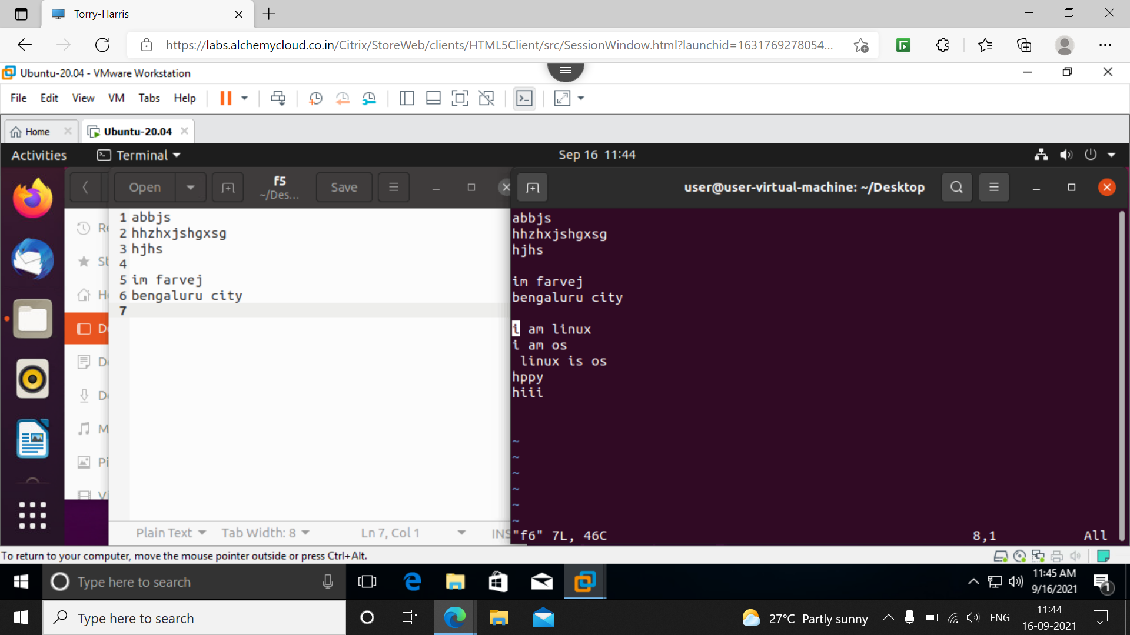

**9] head**

Head is a command used to print the first N lines of data by default it is 10 lines here

In below I have 14 line in f5 file but it prints first 10 lines

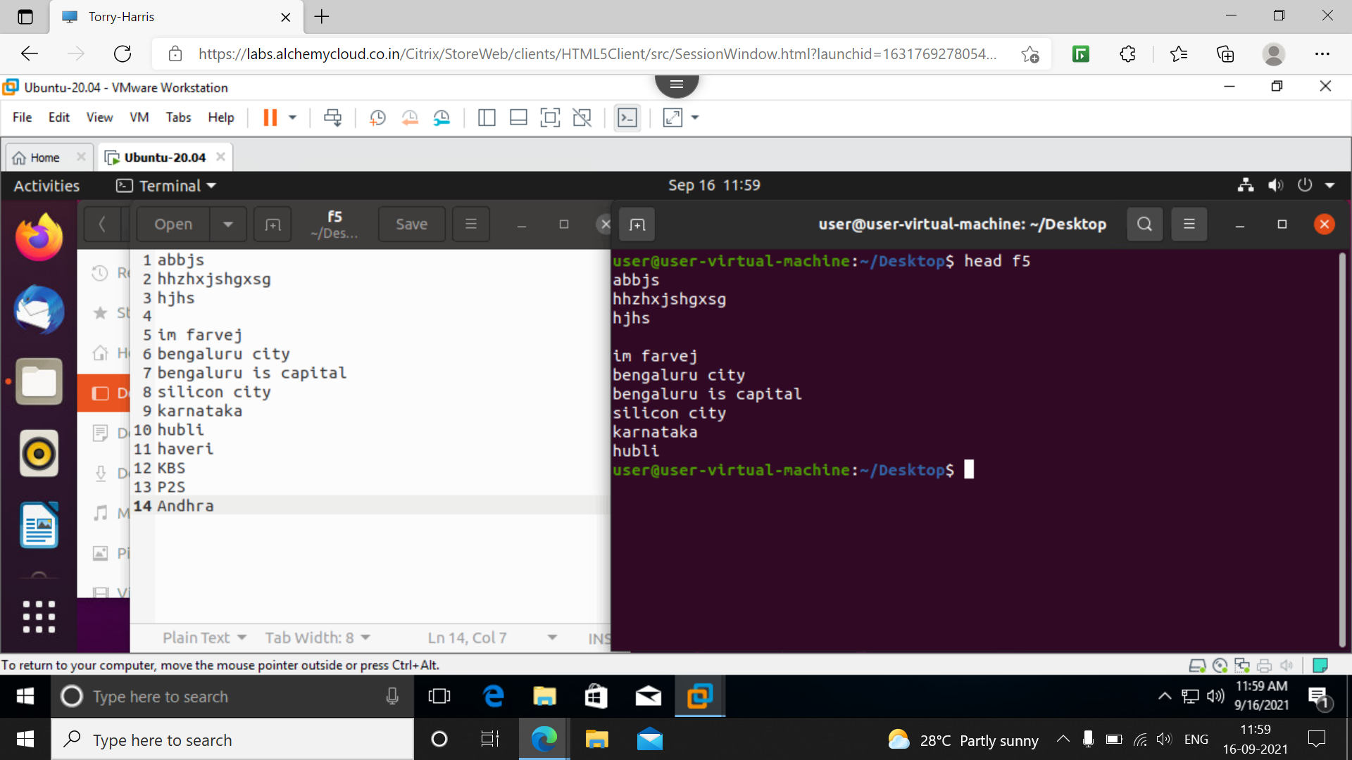

**10] head –n 6 f5**

This command prints first six lines of data in f5 file here –n is used to specify the no of lines required

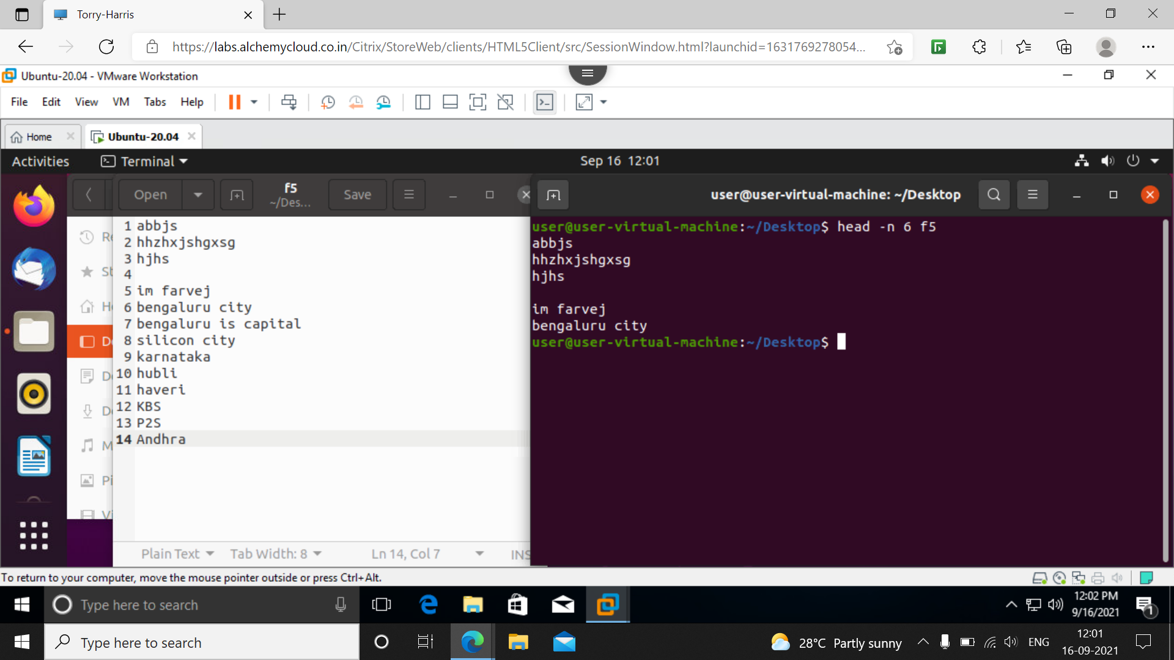

**11] head –q f5 f6**

This prints the data of lines of files f5 and f6 both first 10 lines

s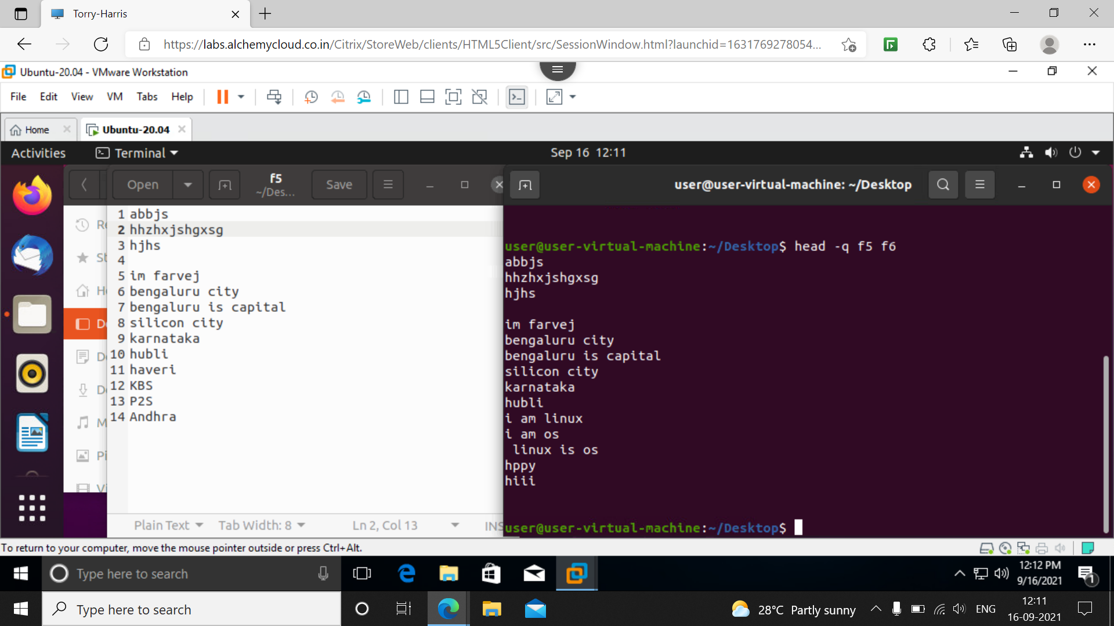

**12] tail filename**

This prints the data in reverse order or last 10 lines of the file

It is negation of head

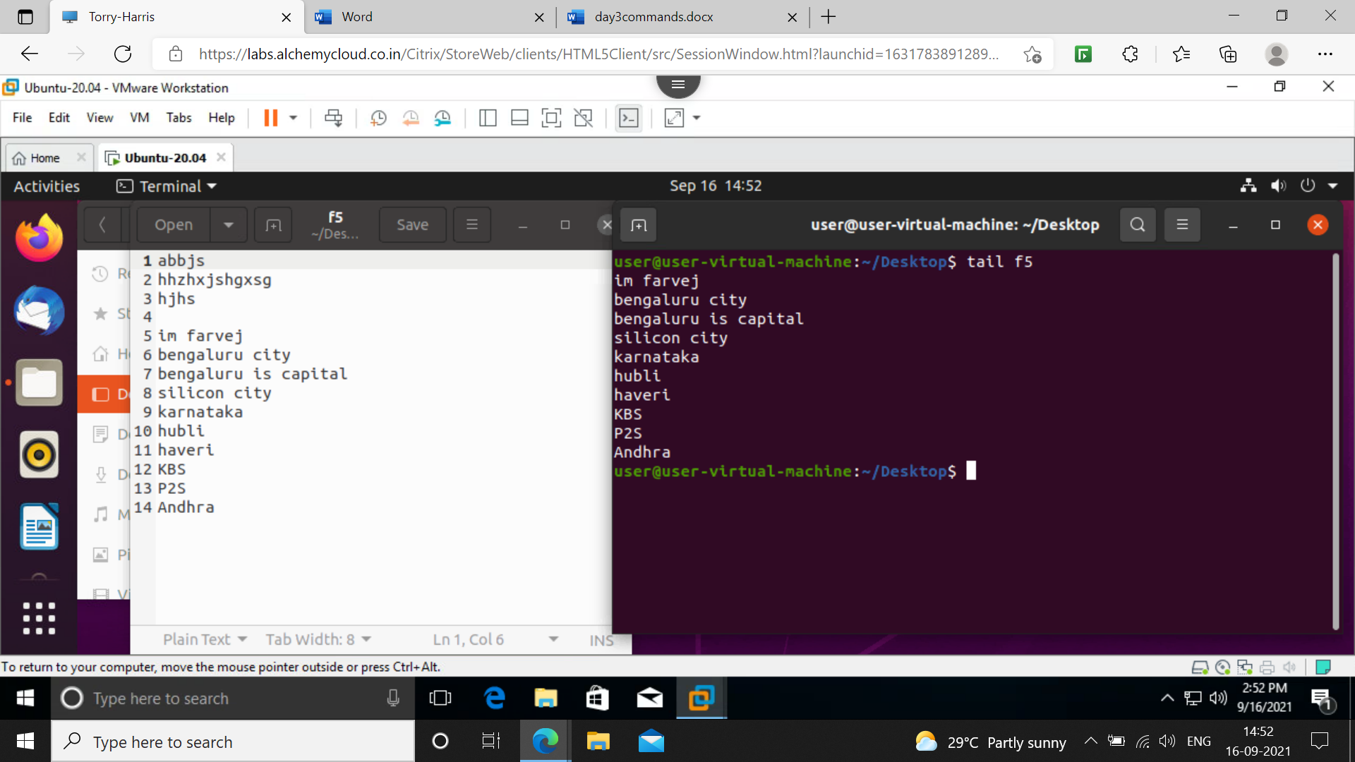

**13] tail –n 5 f5**

**P**rints the last 5 lines of the file f5

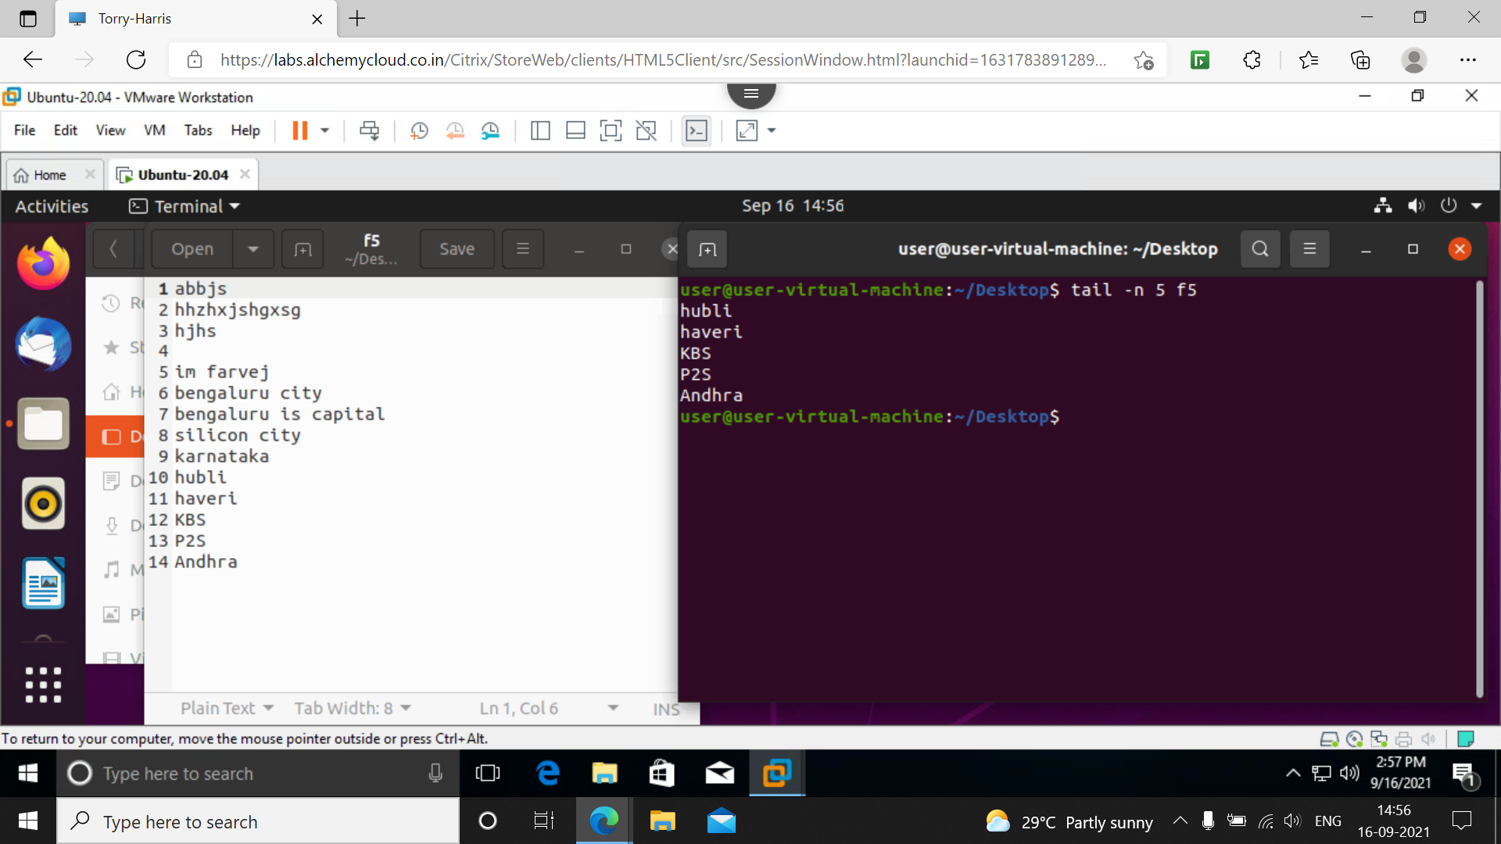

**14] tail –q f5 f6**

**T**his compares both files and print the name list from last from both files

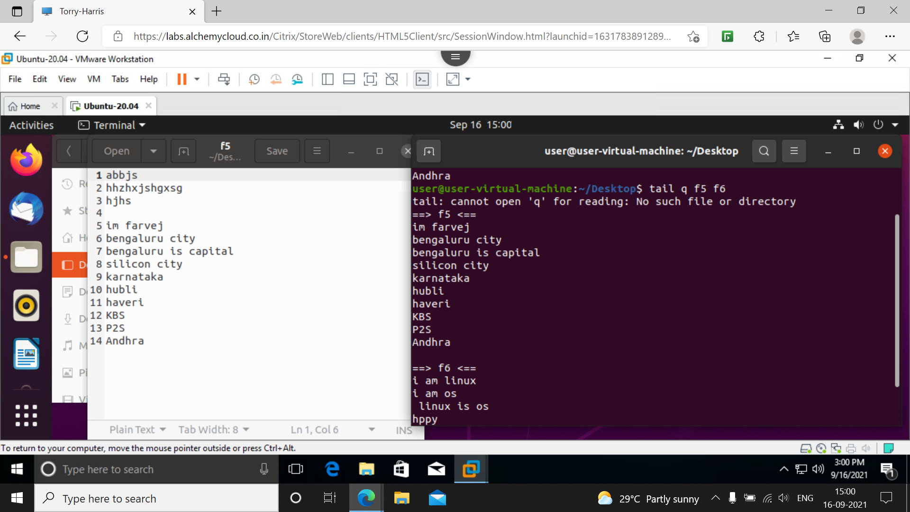

**15] find**

This gives all possibilities of the file we searched

Below I searches for demo file it will give all paths of demo

